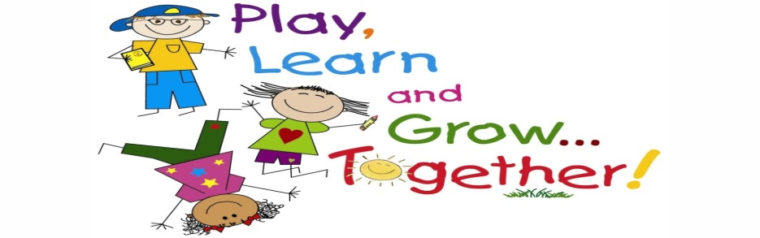

SAINT LOUIS PUBLIC SCHOOLS • EARLY CHILDHOOD DIVISION

314-331-6150

801 N. 11TH, ST. LOUIS, MO 63101

**If you suspect a child of having a disability, the St. Louis Public Schools can open a window of hope for a brighter future.**

**Early Childhood Special Education**

St. Louis Public Schools assures that it will provide a free appropriate public education (FAPE) to all eligible children with disabilities in accordance with The Individual with Disabilities Act (IDEA). Early Childhood Special Education services are provided for all young children with disabilities, in accordance with the Missouri Department of Elementary and Secondary Education.

**Eligibility Criteria**

Any child between three and five years with a demonstrated developmental delay and who meets eligibility criteria in Early Childhood Special Education is eligible to receive services.  If you would like to make a referral for an evaluation or to discuss developmental concerns with an intake specialist, please contact: **Sanceria Thomas: 314-633-5370**.

**Areas of Development reviewed to determine eligibility:**

-Cognitive Development - Academic Achievement

-Communication Development - Assistive Technology

-Physical Development - Sensory Development

-Adaptive Development

-Social or Emotional development

**Least Restrictive Environment**

Your child with a disability should be educated, to the maximum extent appropriate, with children without disabilities.  The IEP must first consider if your child can remain in the general education classroom and achieve the IEP goals and objectives with help of supplementary aids and services.  If the team agrees, this will allow your child opportunities to be integrated with peers without disabilities to the maximum extent possible.